|  |  |  |  |  |  |  |
| --- | --- | --- | --- | --- | --- | --- |
| MWI | | |  | | | |
| **THE HASHEMITE KINGDOM OF JORDAN**  **MINISTRY OF ENERGY AND MINERAL RESOURCES** | | | **AL AMBARATOURIA LI TAKA AL SHAMSIA** | | | |
|  | | | | | | |
| **Project Title:** | | | | | | |
| **DEVELOPING A 50 MWac PV POWER PLANT IN**  **AL MAFRAQ** | | | | | | |
| **Document Title:** | | | | | | |
| **stakeholder engagement plan** | | | | | | |
| **Document Number:** | | | | | | |
| **AMBR-ES-SE-PLN-006-MS-Rev00** | | | | | | |
| **Issue Date:** | | | | | | |
| **30 MAY 2016** | | | | | | |
| MWI | |  | | | | |
| **THE HASHEMITE KINGDOM OF JORDAN**  **MINISTRY OF ENERGY AND MINERAL RESOURCES** | | **AL AMBARATOURIA LI TAKA AL SHAMSIA** | | | | |
|  | | | | | | |
| **INDEX SHEET FOR REVISIONS** | | | | | | |
| **Document Title:** | | **Document Number:** | | | | |
| **stakeholder engagement plan** | | **AMBR-ES-SE-PLN-006-MS** | | | | |
| **REVISION HISTORY** | | | | | | |
| **REV**  **NO** | **DESCRIPTIONS/**  **REASON FOR ISSUE** | **DATE** | | **PREPARED BY** | **CHECKED BY** | **APPROVED BY** |
| 00 | Issued for Info | 30/05/2016 | | RT, AM | KN | KN |
|  |  |  |
| 01 | Issued for Info | 9/8/2017 | | RT | JAJ | JAJ |
|  |  |  |
|  |  |  | |  |  |  |
|  |  |  |

Table of Contents

1 HSE Policy 1

2 Introduction 2

2.1 Background 2

2.2 Project Location 2

2.3 Socio-economic Context of the Project Area 4

2.3.1 Land Use 5

2.3.2 Potential Implications on local community groups 6

2.3.3 Employment Opportunities 8

2.4 Objectives of Stakeholder Engagement Plan 10

3 Regulatory Requirements 11

4 Identification of Stakeholders 13

5 Information Disclosure and Stakeholder Engagement Activities 16

5.1 Summary of Previous Stakeholder Engagement Activities 16

5.2 Collaborative Arrangements 19

5.3 Planned Stakeholder Engagement Activities 20

6 Grievance Mechanism 23

6.1 Public Grievance Mechanism 23

6.2 Employee Grievance Mechanism 27

List of Tables

Table 1: Stakeholder Identification 6

Table 2: Stakeholder Engagement Process 7

Table 4: Planned Stakeholder Engagement Activities 10

List of Figures

Figure 1: Project Area 3

Figure 2: Public Grievance Form 15

Figure 3: Standardized Procedure for Processing Public Grievances 16

# HSE Policy

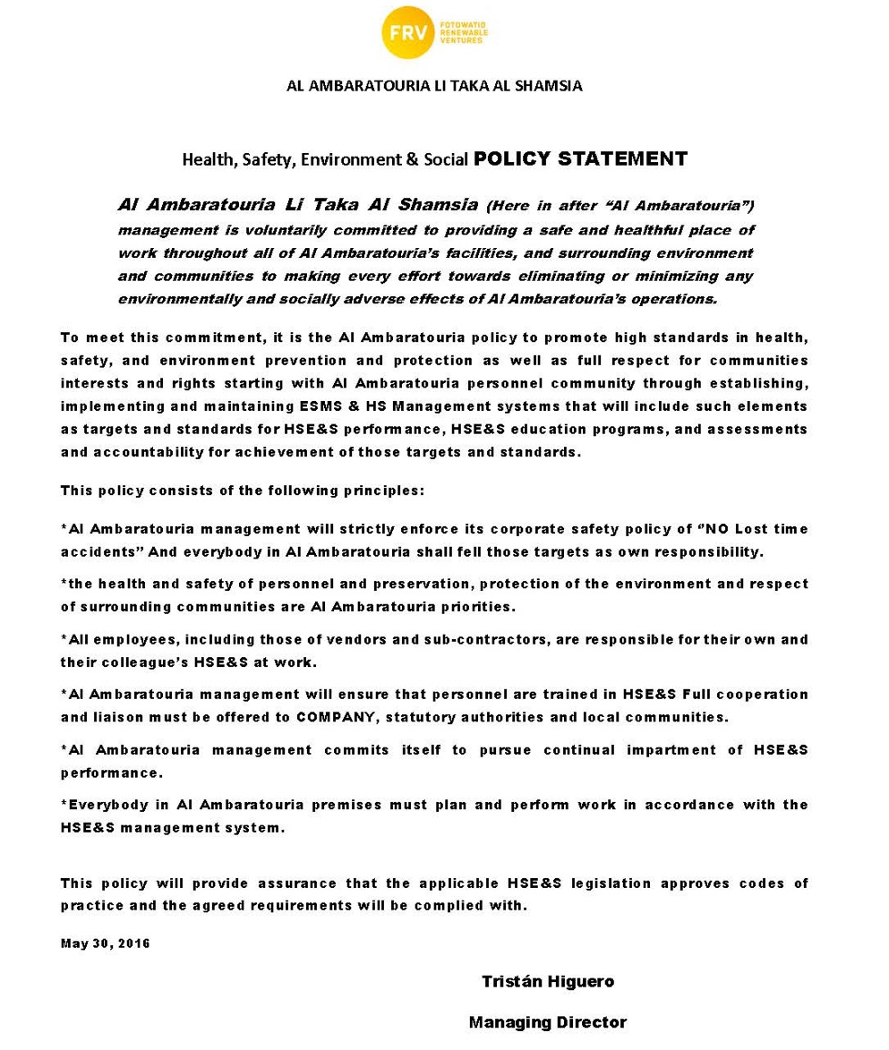

# Introduction

## Background

Al Ambaratouria Li Taka Al Shamsia (referred to as Al Ambaratouria in this report) has been granted an approval from the Government of Jordan, represented by the Ministry of Energy and Mineral Resources (MEMR), to develop a 50 MWac grid connected Photovoltaic project in Mafraq.

Al Ambaratouria aims to develop the solar energy project using PV technology to generate electricity in Jordan. The project will help to decrease the country’s dependency on traditional forms of energy by increasing the availability and use of solar energy. The generated electricity will be injected into the national grid, to support the country in meeting its renewable energy target of 10% by 2020.

MEMR and the National Electric Power Company (NEPCO) have successful track record with independent power projects (IPPs) that include top international power developers with active projects in Jordan.

Arabtech Jardaneh (AJ) was appointed by Al Ambaratouria to prepare the Preliminary Environment Impact Assessment (EIA) Study for the project activities during the three phases of the project namely: construction, operation and decommissioning. The Preliminary EIA is currently underway and will be prepared in accordance with the requirements of the Jordanian Environmental Impact Assessment (EIA) Regulation no. 37 of 2005, and the International Finance Corporation (IFC) Performance Standards as well as the European Bank for Reconstruction and Development (EBRD) Environmental and Social Policy (ESP) which consists of the EBRD Performance Requirements (PRs) in order to support the application for an environmental permit from the Ministry of Environment (MoEnv).

Al Ambaratouria Li Taka Al Shamsia has consequently requested AJ to prepare an Environmental & Social Management System (ESMS) for the above mentioned project. And as part of such requirements and to fulfill EBRD requirements, a Stakeholder Engagement Plan (SEP) is required to be prepapred which is the subject of this document.

## Project Location

Al Ambaratouria project area falls within King Hussein Bin Talal Development Area (KHBTDA) which is located in north of Jordan at Al Mafraq Governorate, KHBTDA was created as trade and Logistics Hub and an Industrial City that serves the regional market and is complemented by housing and commercial & community services. The area allocated for KHBTDA spans over around 21,000 Dunums and provide employment for around 33,795 workers by year 2029, at least 60% of whom are local employees, the area is divided into four major land use categories: The Industrial, the Transit Logistics, the Residential and Community Facilities (Source: Master Plan Report for king Hussein Bin Talal Development Area, June 2008).

Mafraq Development Company (MDC) allocated around 4200 Dunums within the industrial zone in order to develop solar power projects by interested national and/or international companies in this field. Al Ambaratouria Solar project area (plots S3-A and S3-B) is located within KHBTDA and spans over a total of 1,330 dunums (plot S3-A is 1030 dunums and plot S3-B is 300 dunums) within the solar power field as shown in **Figure 1.**

As shown below, plot no. S3- A+B was allocated for Al Ambaratouria to build 50MW PV plant. The nominal capacity of the plant is 50MW AC and will have peak capacity of approximately 65MW DC.

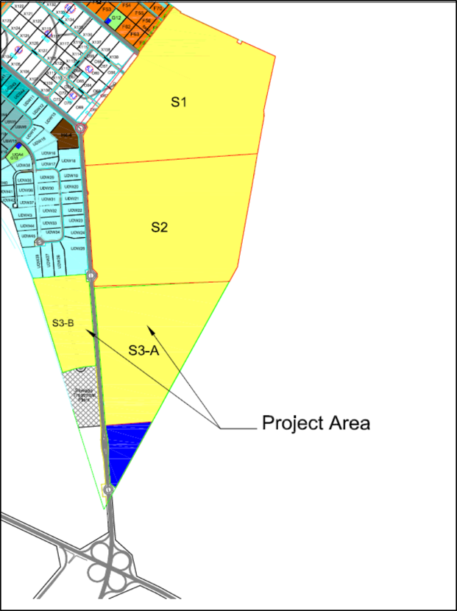

Figure 1: Project Area

## Socio-economic Context of the Project Area

Based on the Preliminary ESIA Conducted for the project and approved by the Ministry of Environment on September 1st 2016, the socio-economic baseline section stated that no Bedouin groups/tribes reside in the project area or in the vicinity, the project area is mainly uninhabited.

The population of Jordanian nationals at Mafraq Governorate in 2015 was estimated at 314,164 which comprises 4.75% of the total Jordanian population in the Kingdom. The number of non-Jordanians within Mafraq in 2015 was estimated at 235,784 comprising 8.08% of the total non-Jordanian population in the Kingdom. As a result, the total population in Mafraq Governorate for 2015 (including Jordanians and non-Jordanians) is 549,948 comprising 5.77% of the total population in the Kingdom. (DoS, 2016)[1].

The estimated percentage (%) distribution of non-Jordanians in Mafraq by nationality is shown in **Table 1** below:

**Table 1: Percentage (%) Distribution of Non-Jordanians in Mafraq Governorate by Nationality**

|  |  |  |  |  |  |  |  |  |
| --- | --- | --- | --- | --- | --- | --- | --- | --- |
| **Governorate** | **Palestine** | **Syria** | **Egypt** | **Iraq** | **Yemen** | **Libya** | **Other** | **Total (%) Non-Jordanians in Mafraq** |
| **Mafraq** | 1.33% | 16.43% | 2.56% | 0.55% | 0.68% | 0.25% | 1.13% | 8.08% |

Source: Dos, 2016

It is worth noting that Mafraq governorate consists of the 3rd largest population of Syrians in Jordan after Amman and Irbid (DoS, 2016).

The nearest populated areas to the project area are Zbaidiyah Village, Ba’ej Village and Zatari Village which fall under the Badiyah Al Shamaliyah Gharbiyah Sub-District. The estimated population of this sub-district in particular is 30,160. (DoS, yearbook 2014).

The area of Mafraq governorate is 26,551 km2, comprising 29.9% of the total area of Jordan, this would result in a population density of 11.6 capita/km2 (DoS yearbook, 2014).

As per DoS yearbook for 2014, the unemployment rate in Al-Mafraq governorate is 15% of total the population of the Kingdom compared to 14.5% in 2013, the rate of unemployment between males is 12.3 % while the unemployment rate between females is much higher within Al- Mafraq governorate which is 26.2%. The percentage of unemployed females has risen from 2013; while the percentage of unemployed males remained the same from 2013.

### Land Use

The project area is located within KHBTDA and classified as industrial area. The plots allocated for solar projects are currently empty of any official use according to KHBTDA as shown below.

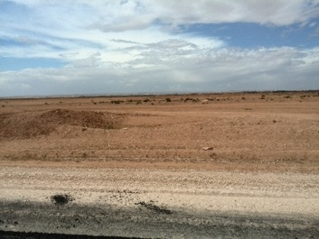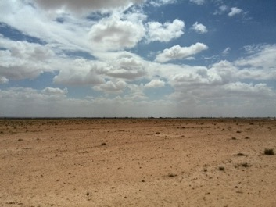

**Figure 2: Photos from the project site**

As shown below the nearest populated area to the project site is Al Zbaidiyah Village which is located around 2.3 km north to the project site. Al Mafarq city is located around 6.1 km to the west while Al Ba’ej Village is located around 3.6 km north east of the project site and Al Zatari village is located 2 km south east to the project area.

According to the analysis made in the Preliminary ESIA, the project is not expected to cause any serious impacts to such communities; given that the MDC recently fenced the KHBTDA therefore, the project site is secure and access is controlled. As part of the ESMS documentation developed for this project, a Community Health and Safety Plan has been prepared, and it has been concluded that the main community that is expected to be in direct contact with the project is the project personnel and the investors in the vicinity of KHBTDA. No direct community residents/locals/vulnerable groups are expected to be significantly affected by project activities. The nuisances that they may be exposed to on short-term basis during construction are traffic congestion at certain times, noise and dust and general disturbance.

In addition, security personnel will be employed on site through a private security company and appropriate measures and procedures proposed in the Security Management Plan (SMP) and Security Risk Assessment developed for this project will be applied accordingly.

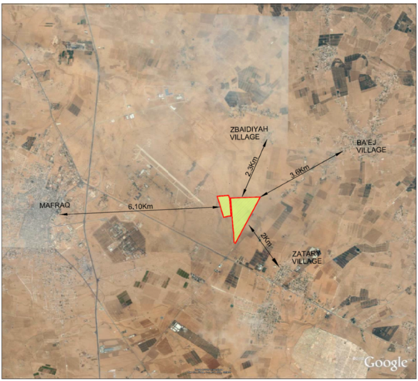

**Figure 3: Project Site and Nearby Populated Areas**

### Potential Implications on local community groups

The surroundings of the project area have witnessed intermittent and informal use of land by some herders to feed their herds as shown in below. As confirmed by an MDC representative that such groups of herders utilize this area occasionally and escort their herds to move in the surroundings of the project area.

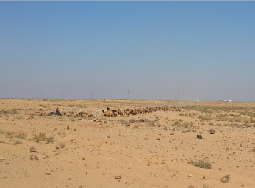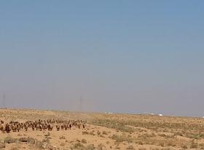

**Figure 4: Group of herders utilize the surroundings of the project area**

The carrying capacity of land in Jordan is considered low; and the figure below illustrates the land around the project area within a 10 km radius which is available for forage and agricultural activities. As shown in below, the forage and agricultural areas is around 16 km2 compared to 78 km2 area of the 10 km radius, which means that within the 10 km radius 20.5% is considered suitable for fodder and agricultural activities. Therefore, if we compare the project area (1.33 km2) to the agricultural and forage areas (16 km2), we find that the area of the project constitutes 8.3% of the forage and agricultural surrounding area.

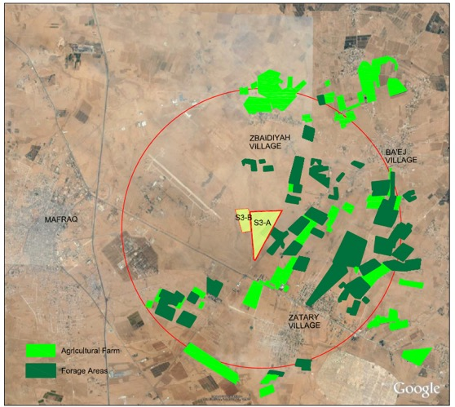

**Figure 5: Surrounding 10 km Radius to the Project site showing Cultivated Areas**

After further analysis in the Preliminary ESIA, it is determined that livelihood restoration is not required due to the following justifications:

**Category 1: Physical Displacement**

No physical displacement will occur within the project area because the project will be developed inside KHBTDA and at a designated zone for solar PV power production. In addition, installment of the fence around the project area would not affect the access or mobility of nearby local populations since MDC has recently completed the wall around the whole KHBTDA in order to control the access inside the development area. In addition, the surrounding villages are connected between each other and with Mafraq governorate through a network of paved roads.

**Category 2: Economic Displacement**

* **Loss of Assets:** As mentioned in the baseline section the randomly livestock fodder cultivation activity that has been observed at smaller parts of the project area and its surroundings is not considered as a permanent asset for the local community where regular farming and cultivation occurs at the eastern side of the KHBTDA. The project area is considered small compared with the area available for forage as demonstrated in **Figure 5** above, therefore local herders are not considered eligible for compensation because the carrying capacity of the natural forage is naturally low which means it was not a free food resource for animals, and usually when herders utilize the area they plough the area and buy the seeds which is the same cost that they have to pay either inside KHBTDA or outside. Also there are similar lands with similar characteristics that are closer to their villages.
* **Loss of access to assets:** The KHBTDA is government owned land that is under the management of MDC. The previous owner for this area was the military air force where KHBTDA was an integral part of the air force area that was allocated by the army to the government in order to establish the development area and to enhance the socio-economic status of Mafraq and the surrounding communities. Therefore, such land was never a historical asset for the locals, therefore, the development of the project at the proposed location does not comprise any losses for the local community.
* **Loss of income sources or means of livelihood:** The project area was not accessible by the local community before being allocated as part of KHBTDA because it was under military control and was considered as a military zone. However, and during the establishment of KHBTDA, the area did not support the livelihood of the surrounding communities in a structured and continuous manner, although they previously has an open access to pass through the area, with their herds moving from between the eastern and western sides of KHBTDA where they perform their regular agricultural at these farmlands are available will not cause loss of income sources of means on livelihood, but currently the KHBTDA is fenced and secure now, therefore, no impacts from the project on the herders within project site and surroundings will occur, as there are no economic income obtained by them from the project land. Additionally, the Preliminary Environmental Assessment report conducted for KHBTDA in 2014 indicated that the KHBTDA area has low agricultural potential and the proposed project activities will not have any significant effect on this status.

### Employment Opportunities

Positive benefits of the project may arise from short-term job opportunities during construction which may reach up to 500 jobs at peak where 90% are unskilled workers and 10% are skilled – which will be mainly engineers and technicians. For the 90% workers, priority will be given to the local community at Mafraq and local Jordanians in the market, otherwise, foreigners such as Egyptian workers (as it is the current case in Jordan).

Regarding refugees, the project may create a potential for having opportunities when the government of Jordan during construction when the government of Jordan starts implementing the mechanism of employment of Syrian refugees in the Jordanian market, however, such implementation/governmental plan has been considered priority for locals as well the project will do. In terms of gender issues, the job opportunities during construction is mainly limited to men due to required physical efforts and other cultural considerations, therefore jobs available to local men can benefit women directly through support services such as a) renting homes; b) selling goods and products indirectly through benefiting from income from the job provided for the spouse or head of the household.

The impact is assessed as positive in the Preliminary ESIA report; however, will be short-time during the construction period. Maximizing the impact can be through selecting local staff as much as possible or sourcing goods and services from locals.

During the Operation Phase, the long-term operation of the PV power plant will provide specialized employment and training for a small local workforce (approximately 10 full time employees) to be hired as part of Al Ambaratouria’s operator’s team. However, these opportunities are assumed to be limited in number and require people with certain technical qualifications. Although this impact is considered as positive, however it will only employ a small number of employees; therefore, the amount of locals being employed during operation is relatively low. However, to maximize this impact, it is worth noting that as a Corporate Social Responsibility (CSR) initiative implemented by the company and jointly the other developers (i.e. ACWA Power) at KHBTDA; Al Ambaratouria agreed with MDC and local authorities to have the training centre inside the development area soon in order to have people ready as many as possible to be trained and ready to work if needed (number of trainees might be more than what the developers need, but the people will have experience and can work anywhere else and the developers will have options based on their needs). The 3 developers within KHBTDA will contribute in the cost of establishing the training center inside the area, MDC will manage it and prepare all courses for it. MDC is considered the lead on CSR initiatives, although it does not have a defined CSR plan, usually a certain budget is allocated for each year employed by MDC in accordance with actual needs.

It is also recommended that the 3 developers seek coordination where possible in order enhance the skill of the local workforce. As part of the ESMS documentation for this project, a Community Development / CSR Plan has been prepared which included a framework for developing community development alternatives.

Regarding refugees, the project may create a potential for having opportunities when the government of Jordan during operation when the government of Jordan starts implementing the mechanism of employment of Syrian refugees in the Jordanian market, however, such implementation/governmental plan has been considered priority for locals as well the project will do.

## Objectives of Stakeholder Engagement Plan

Stakeholders are identified as any individual and/or group that could be affected by the proposed project activities and has interest in their outcome. According to this definition, the stakeholders may include property owners, business owners, central government and local officials, special interest groups, and non-government organization.

Objectives of the stakeholder engagement plan include:

* Identifying the main stakeholders of the project components and activities;
* Provide the opportunity for identified stakeholders to participate in the process of identifying any potential impacts and/or concerns;
* Identify those environmental and social impacts/concerns which are considered to be of key relevance and importance through a process of information disclosure and meaningful consultation as per EBRD and IFC requirements;
* Ensure appropriate approach and adequate focus is adopted during the project implementation;
* Ensure that the identified stakeholders are appropriately engaged on issues that potentially affect them in addition to managing the Public Grievance mechanism that will be adopted by Al Ambaratouria during the project implementation, especially during construction;
* Establish and maintain an ongoing relationship with the communities affected (positively or negatively) throughout the life of the project.
* Ensure that the community grievance mechanism is accessible;
* Establish, maintain, and improve the worker-management relationship through ensuring that the workers grievance mechanism is accessible, and workers/employees concerns are addressed in a timely manner.
* Engaging with existing workers and/or workers organisations whenever applicable in accordance with the Jordanian Labour Law.

# Regulatory Requirements

The EBRD and IFC consider stakeholder engagement as an essential part of good business practice and a way of improving the quality of projects. As a result, the implementation of the proposed force main project should comply with the EBRD / IFC requirements, specifically EBRD Performnce Standard 10: Information Disclosure and Stakeholder Engagement and IFC Performance Standard on Environmental and Social Sustainability as well as Jordanian local laws and regulations. Stakeholder engagement will be an ongoing process throughout the project, in order to ensure transparency with all stakeholders that may be affected by, or have influence on, the project.

The relevant national and international applicable standards and guidelines within the context of the proposed force main project include, but are not limited to, the following:

1. EBRD Environmental and Social Policy – Performance Requirement 10: Information Disclosure and Stakeholder Engagement.
2. EBRD’s Grievance Mechanism Guidance Note;
3. Environment Protection Law No. 52/2006 as well as the Environmental Impact Assessment Regulation No. 37/2005;
4. Stakeholder Engagement: ‘A Good Practice Handbook for Companies Doing Business in Emerging Markets’, IFC, May 2007.
5. IFC Performance Standards on Environmental and Social Sustainability, IFC, January 2012.
6. Jordanian Labour Law No. 8, 1996 and its amendments, including Health & Safety regulations and instructions as part of the law;
7. The National Integrity Charter.

In order to fulfill EBRD and IFC requirements, it is recommended that Al Ambaratouria follows a stakeholder engagement process or procedures to ensure effective communication with internal and external stakeholders and take them into consideration in the decision making process and future planning.

# Identification of Stakeholders

In order to define a communication process in line with EBRD and IFC requirements, this section identifies stakeholder categories and affected parties and activities related to the project, these are presented in **Table 1** below.

**Table 2: Stakeholder Identification**

| **Stakeholder Category** | **Stakeholders** |
| --- | --- |
| **Internal Stakeholders** | |
| Employees | This includes relevant Al Ambaratouria female and male employees such as Managers, Engineers, Technical Staff, maintenance, secretaries, administrative personnel, etc. |
| Workers | Temporary and permanent workers at Al Ambaratouria. |
| Operators | Operators responsible for the daily operation and maintenance of the PV plant. |
| Contractors / Sub-contractors | Contractors and sub-contractors working with Al Ambaratouria on this project. |
| **External Stakeholders** | |
| National Government | Ministry of Environment, Ministry of Energy and Mineral Resources, Ministry of Municipal Affairs, Ministry of Health, Ministry of Labour, Ministry of Transport (traffic department), Ministry of Public Works and Housing, Ministry of Agriculture, etc. |
| Local Government | Municipalities such as Mafraq Municipality |
| Community Members | Community leaders, employed men and women, herders and farmers, households males and females, employed and unemployed labour force, youth and students as well as Syrian Refugees. |
| Mafraq Development Company (MDC) | Responsible to manage the KHBTDA and coordinate with project developers and investors.  It is worth noting that the MDC currently does not have an official / recorded stakeholder engagement process with the local community or local municipalities. Usually, the Investment Commission in Amman is responsible for following-up and coordinating with local municipalities and obtaining the required licenses and approvals on behalf of MDC and other development zones commissions in Jordan. Furthermore, Governor of Mafraq and other administrative district governors are responsible in communicating with MDC in case of any complaints, or other issues faced by the local communities such as jobs and so on. The MDC does not have a formalized public grievance mechanism. |
| Industries / developements | Neighboring industries and developments located in close proximity to the project i.e. mainly within KHBDA. |
| Trade | Trade association groups, cooperatives, credit institutions, banks, businesses, business owners, tourism, agriculture, private health business, and public services companies |
| NGOs | This category includes local CBOs, local woman organisations, local cooperation societies, Farmers Society /association. |
| International Agencies | This includes international funding agencies that are funding projects in the area examples include: the International Finance Corporation (IFC), European Bank for Reconstruction and Development (EBRD) and Proparco. |
| Academic | Universities and Research Institutes. |

The stakeholder engagement activities will be carried out as follows:

* Project stakeholders and all parties affected or related to this project will be identified;
* Public meetings and documentation of their results will be conducted;
* Stakeholders impacted by the project works will be consulted; and
* Public documents will be publically disclosed and made easily accessible.

Stakeholder engagement will be carried out by Al Ambaratouria internally and externally. All anticipated stakeholders, communication methods and proposed media for each stakeholder are shown in the following table:

**Table 3: Stakeholder Engagement Process**

| **Stakeholder Category** | **Communication** | **Proposed Media** |
| --- | --- | --- |
| **Internal Stakeholders** | |  |
| Employees | Workshops, employee meetings/annual meetings, information sheets, etc. | Al Ambaratouria company website (intranet), internal e-mails, internal newsletter. |
| Construction workers | Onsite advertisement, bulletin board | Brochures, leaflets |
| Contractors and sub-contractors | Meetings | Emails, official invitation, information in contract |
| **External Stakeholders** | | |
| Local authorities | Workshops, disclosure meetings, focus group discussions. | Official invitation letters, identify the venue location and time of meeting. |
| Trade / NGOs / International Agencies | Disclosure meetings, workshops | Notified through newspapers, radio stations, Al Ambaratouria company website, or official letters |
| Targeted local community members, vulnerable groups (youth and unemployed groups (men and women) and concerned livestock herders | Disclosure meetings, focus groups, individual meetings  Public consultation meetings (in case of grievance)  And during the construction of the project, grievances and concerns of local community (including vulnerable groups and livestock herders) can be communicated through the grievance mechanism explained under section 6.1. | Newspaper, radio station, Al Ambaratouria company website, brochures |
| MDC | Meetings | E-mails, official letters |

# Information Disclosure and Stakeholder Engagement Activities

## Summary of Previous Stakeholder Engagement Activities

AJ team has prepared the Preliminary EIA for this project and the approval from the Ministry of Environment has been issued on September 1st 2016, as a result, several consultation sessions has been conducted during June 2016. . The outcomes of these consultations are discussed below.

The Table below demonstrates the consulted stakeholders during the Preliminary ESIA process:

**Table 4: Consulted Stakeholders**

| **No** | **Consulted Party** | **Name of Party Representative** | **Date of Meeting** |
| --- | --- | --- | --- |
| 1 | Development Unit – Mafraq Governorate | Ibtisam Omoush | 12/6/2016 |
| 2 | Al Ard Al Taybeh Socity  Mafraq Municipality | Eng. Hayel Al Omosh | 12/6/2016 |
| 3 | Jordan Chamber of Commerce- Mafraq | Abdullah Nwayyfa’ | 29/6/2016 |
| 4 | Mafraq Vocational Training Center | Eng. Mohammed Al Khaldi | 29/6/2016 |
| 5 | The Jordanian Hashemite Fund for Human Development (JOHUD) | Widad Al Shraydeh | 29/6/2016 |
| 6 | Sama Al Badia Organisation | Dina Al Khaldi | 29/6/2016 |
| 7 | All Jordan Young Commission - Part of King Abdullah II Fund For Development (KAFD) | Mohammad Sarhan | 29/6/2016 |

The areas of discussion with the above mentioned stakeholders on June 12th were as follows:

* **The mechanism at Mafraq Governorate for organizing relations between investors and local community**.

The governorate mainly acts as an umbrella for facilitating and supporting any investment for community development through different formulated committees that define community needs and present such needs in order to fulfill such needs in a sustainable manner; this activity is managed by the development unit within Mafraq Governorate.

* **The relation between MDC and investors pertaining to the involvement of the local community.**

The MDC liaises between investors and local community organizations; and MDC is set to manage the training center that will be established within the KHBTDA similar to what has been established in Ma’an Development Area. The training center will train locals to be ready to work if needed and to have experience where the developers will have options to select from locals based on their needs. The 3 developers within KHBTDA will contribute in the cost of preparing the training centre inside the area, MDC will manage it and prepare all courses for it.

* The communication of Non-Governmental Organizations (NGOs) and Community Based Organizations (CBOs) is through MDC or Mafraq Governorate who in turn convey / present their needs to the developers.
* Based on the above consultations, the renewable energy projects in Mafraq are viewed as a benefit to society and economy, where production costs can be minimized, capability of creating more employment and establish community development programs; and higher budget allocation.

The areas of discussion with the stakeholders consulted on June 29th were as follows:

* All consulted stakeholders encouraged the project’s idea, look forward to seeing the benefits on the local community such as jobs and are keen to see a change in the reduction of production costs, improvement in the local economy. In general, they believe that such projects will help to develop Mafraq Governorate in the future.
* Emphasis was placed on the importance to engage the younger generation/graduates and youth in jobs, and encouraged the idea of the PV training center that will be managed by MDC and financed by the solar projects developers, it can help community members to learn new skills that would help them find jobs (regardless of whether they were employed at one of the solar projects or elsewhere).
* They expressed concerns from Syrian refugees to reduce job opportunities for locals due to competition; and emphasized the need to increase work opportunities in Mafraq, especially for young men and new graduates.
* The Mafraq Vocational Training Center specifically expressed concern that some employers/industries are not committed to hire from the local workforce.
* JOHUD stated that part of their objectives is to help link job seekers with employers in Mafraq; they provide training courses for job seekers and can also help employers find the right candidates for certain jobs.
* All consulted parties stressed the importance of locals at Mafraq benefitting from different work opportunities at the KHBTDA.

The Figures below are some photos illustrating some of the consultation meetings that were undertaken.

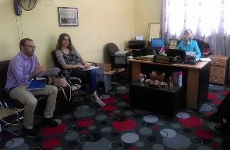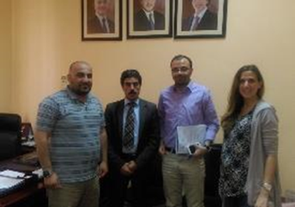

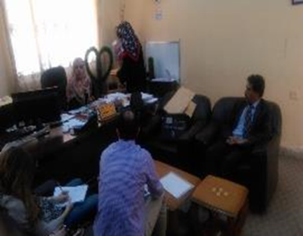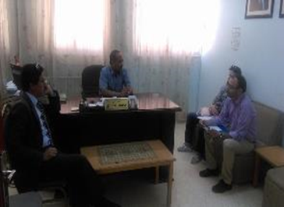

**Figure 6: Photos Illustrating Consultation Activities**

As for previous consultations, a scoping session was carried out on November 15th 2015 as part of the Environmental & Social Impact Assessment (ESIA) study for the adjacent land plot (S2) for a 50 MW PV power plant project as well. AJ was assigned to conduct the ESIA study on behalf of FRV Solar Holdings IX B.V./Jordan.

The outcomes and deliberations of the scoping session are discussed in detail in the ESIA report for the project which was approved by the Ministry of Environment in March 2016.

## Collaborative Arrangements

During the Preliminary ESIA process, it was found that there was no official / recorded stakeholder engagement process at MDC with the local community or local municipalities. Usually, the Investment Commission in Amman is responsible for following-up and coordinating with local municipalities and obtaining the required licenses and approvals on behalf of MDC and other development zones commissions in Jordan. Furthermore, Governor of Mafraq and other administrative district governors are responsible in communicating with MDC in case of any complaints, or other issues faced by the local communities such as jobs and so on. The MDC does not have a formalized public grievance mechanism.

However MDC can support with the disclosure of relevant project information such as the Non-Technical Summary and the Stakeholder Engagement Plan to enable any potential stakeholder to learn of the project and obtain a copy of the grievance form.

It is also recommended that Al Ambaratouria to establish lines of communication with MDC and other developers at KHBTDA (I.e. ACWA) whereby information about grievances can be shared and, only where appropriate, dealt with at the whole solar site level. i.e if MDC or either project receives any complaint that requires joint consideration by ACWA and Al Abaratouria, then projects can cooperate, but if the complaint is project specific, normal project specific procedures can be applied.

As mentioned in the next sections, Al Ambaratouria will assign a Community Liaison Officer (CLO) which will be responsible for handling grievances and overseeing community related matters for the project.

There is also a collaboration between Al Ambaratouria, FRV, MDC and ACWA Power for the water connection and the interconnection line to the substation, where MDC, National Electric Power Company (NEPCO), Al Ambaratouria, FRV and ACWA Power FRV as well as Orange the telecom company are in the process to agree on the interconnection route, to ensure that each developer not trespass the cables of the other, and the routing of each developer’s cables were determined and agreed with NEPCO.

Also, as previously mentioned Al Ambaratouria, FRV and ACWA Power agreed with MDC and local authorities to have a training centre inside the KHBTDA in order to train locals and support their readiness and training skills in PV technologies ready as much as possible to be ready to work where needed.

## Planned Stakeholder Engagement Activities

The table below presents a proposed programme for stakeholder engagement and the activities to be performed throughout the project to ensure that all stakeholders are informed of the project and are engaged and aware of their rights and the mechanism for voicing out their concerns. It is also recommended that Al Ambaratouria to coordinate with developers at KHBTDA in the below activities so ass to maximize their benefits to potential stakeholders.

**Table 5: Planned Stakeholder Engagement Activities**

| **Stakeholder Engagement Activity** | **Type of Information Disclosed / Method of Engagement** | **Potential Locations** | **Stakeholder Groups to be Consulted/Engaged** |
| --- | --- | --- | --- |
| **During Preliminary EIA Stage** | | | |
| Consultation sessions | The Preliminary EIA has already conducted relevant consultations with selected individual stakeholders and stakeholder groups as shown in the previous section. | Public venue in Mafraq / or during site visits to the project area. | * Local community members, authorities. |
| **Prior to Construction** | | | |
| Meetings with Employees | Create an open forum to ask direct questions to Al Ambaratouria management.  Inform them of the available grievance mechanism and how they can access it. | Public venue in Mafraq or at MDC premises. | * Employees and workers (temporary and permanent) at Al Amabaratouria. * Contractors / Sub-contractors |
| Contractors/sub-contractors and temporary workers/operators | Agree of grievance management to be practiced during construction, inform all stakeholders, code of conduct for temporary workers, conduct relevant trainings at MDC premises if suitable. | Public venue in Mafraq or at contractor’s premises | * Contractors and temporary outsourced workers |
| Consultation with relevant governmental institutions | Discussion of permits required and other monitoring requirements that will be needed for construction. | To be determined. | * Relevant ministries and municipalities. |
| **During Construction** | | | |
| Communication with local community members, vulnerable groups (youth and unemployed men and women and Syrian Refugees) and concerned livestock herders. | Contractor to maintain an open communication channel throughout the construction phase with local community members in case of complaints / grievances, and respond to any concerns or grievances communicated through the adopted grievance mechanism. | On site. | local community members. |
| **Operation Phase** | | | |
| Meetings with Employees specially who are involved in operation and maintenance activities. | Inform them of the available grievance mechanism and how they can access it. | Al Ambaratouria premises. | * Employees and workers (temporary and permanent) at Al Ambaratouria. |
| Al Ambaratouria performance in operations phase | Annual update and reporting on the Environmental & Social Action Plan (ESAP) | Company Reports, periodic meetings with Internal Stakeholders (e.g. community liaison officers, operators) to review performance and consider issues raised by stakeholders. | * Internal stakeholders, and external stakeholders (local communities, suppliers). |
| * **During all project Phases** | | | |
| Disclosure of all environmental and social annual reports made | Reports disclosed on Al Ambaratouria website or EBRD website for a certain about of time for potential feedback in any and to enable stakeholders to download the grievance form.  In addition, MDC can make the Stakeholder Engagement Plan available at its premises duringa certain period for stakeholders feedback. | Online and at MDC premises. | * Open to all. |

# Grievance Mechanism

## Public Grievance Mechanism

Al Ambaratouria must adopt a formalized public grievance mechanism to monitor and promptly resolve any potential conflicts with stakeholders whose interests may be affected, and to ensure that all comments and complaints from any stakeholder are considered and addressed in an appropriate and timely manner.

Formalizing a public grievance mechanism will help Al Ambaratouria to effectively reduce potential exposure to risks and costs, and help to address relevant and eligible concerns/complaints before they escalate, in addition it will enhance Al Ambaratouria’s reputation and sustain its role in social responsibility.

More specifically, Al Ambaratouria’s Public Grievance Mechanism must consist of the following:

* Assigning responsibility: responsibility for dealing with community grievances will be assigned to a Community Liaison Officer (CLO) assigned by Al Ambaratouria. Each complaint whether from an individual or an entity will be considered and a response to each specific complaint will be directly communicated to the party that raised it. A sample of a Public Grievance Form is shown in **Figure 2** below.
* The comments of complaints will be summarised and listed in a formal database/register containing the name and contact of the person/community group or entity/industry who made the complaint, and the date of response sent to the complainant (timeframe for acknowledgement). Any person or entity may send comments and/or complaints in person, via a specific and specialised channel announced by Al Ambaratouria or its CLO. The complainant must also be provided with proof of receipt of the complaint.
* All comments and complaints will be responded to either verbally or in writing as specified by the person or entity that made the complaint, as per the grievance form below.
* Al Ambaratouria and/or the assigned CLO will investigate the complaint’s legitimacy/eligibility for validation purposes. The extent of the review will depend on how problematic the complaint is. All received complaints will then be organized them into categories.
* Once the grievance is investigated and clarified, Al Ambaratouria will develop and decide resolution options and prepare a response. Each compliant will be addressed based on the nature of grievance, moreover, grievances will be acknowledged within a reasonable time i.e., 5 days, and then responded to within a reasonable period i.e., 20 working days. Meanwhile, individuals/entities have the right to request that their name to be kept confidential.
* If the claim was rejected for reasons such as being ineligible, has no basis or no action is required, then Al Ambaratouria and/or the CLO must put together a diplomatic response explaining the reason for rejection to the complainant with evidence where applicable.
* Complaints shall be closed when an agreement is reached with the complainants. This shall be recorded in the grievance log or database accordingly, along with the closing date, and any other supporting documentation of photos to be stored for future reference.

As for the construction phase of the proposed PV power plant project within KHBTDA, grievances relating to construction activities will be managed by contractor/s, and supervised by Al Ambaratouria or a third party who will be responsible for managing and supervising the works and activities of the contractor, ensuring that construction activities are carried out in compliance with the project’s requirements, bid documents and the requirements and procedures set forth by the relevant Environmental and Social documents / action plans. Al Ambaratouria shall ensure that any potential health, safety, environmental hazards and social concerns related to the project are controlled and properly addressed.

Furthermore, local communities, residents, adjacent industries, business owners and so on will be informed about the contractors’ contact information prior to commencement of construction activities.

A public grievance standardized procedure is shown in **Figure 3** and shall be used as guidance during implementation of the public grievance mechanism.

**Figure 7: Public Grievance Form**

|  |  |  |  |  |
| --- | --- | --- | --- | --- |
| **Reference No:** |  | | | |
| **Full Name** |  | | | |
| **Contact Information**  **Please mark how you wish to be contacted (mail, telephone, e-mail).** | * **By Post: Please provide mailing address: ___________________________________________________________________________________________________________________________________________________________________________** * **By Telephone: _______________________________________________** * **By E-mail _______________________________________________** | | | |
| **Preferred Language for communication** | * **Language 1 (specify)** * **Language 2 (specify)** | | | |
|  |  | | | |
| **Description of Incident or Grievance:** | | | What happened? Where did it happen? Who did it happen to? What is the result of the problem? | |
|  | | | | |
| **Date of Incident/Grievance** | |  | | |
|  | | * **One time incident/grievance (date _______________)** * **Happened more than once (how many times? _____)** * **On-going (currently experiencing problem)** | | |
|  |  | | | |
| **What would you like to see happen to resolve the problem?** | | | |  |
| Signature: _______________________________  Date: _______________________________  **Please return this form to:**  [name], Health and Safety Manager, or Community Liaison Officer [company name],  Address __________________________  Tel.: _________ or E-mail: _________ | | | | |

Source: European Bank for Reconstruction & Development (EBRD) Grievance Management Guidance Note



**Figure 8: Standardized Procedure for Processing Public Grievances**

## Employee Grievance Mechanism

The employee/worker grievance mechanism will allow employees to address workplace disputes or concerns in a fair, easily accessible and transparent manner. Although an employee grievance mechanism must be in accordance with the Human Resources (HR) policy, the following is a standardized procedure for employee grievance applicable to Al Ambaratouria employees in addition to the operator and contractor employees.

The employee grievance mechanism must take into account the following:

* The employee must be aware of the responsible person that will be responsible to receive complaints. Details about the procedures should be clear and easily accessible in policies or employee handbooks.
* The employee has the right to keep the process of filing a grievance confidential and to appeal to a higher level of management if he or she is not satisfied with the initial findings.
* The employee has the right to express his or her grievance to workers organisations to protect their rights.

A brief procedure for filing a grievance is listed below and shall be used as a guidance throughout the project:

* When a concern or an action has occurred the employee/worker must file a written grievance to his or her supervisor within 5 working days.
* The direct manager has 5 working days to respond back. If the employee/worker was not satisfied with the supervisors’ response, he/she can direct the grievance to the HR Department.
* The HR has 7 working days to respond back. If the employee/worker was not satisfied with the response and wishes to appeal, he or she can direct the grievance to higher level or management within 7 working days of receiving the HR’s response.
* If the employee was not satisfied with the response of top management, then he or she can approach the workers organization (that he or she belongs to) where applicable for further advice and assistance.
* If an employee is not satisfied with the final determination of the internal grievance procedure, the employee can still hire a lawyer and resolve the issue at court.

1. Obtained from the published Population & Housing Census main findings report conducted in 2015 and issued by the Jordanian Department of Statistics (DoS) in 2016.